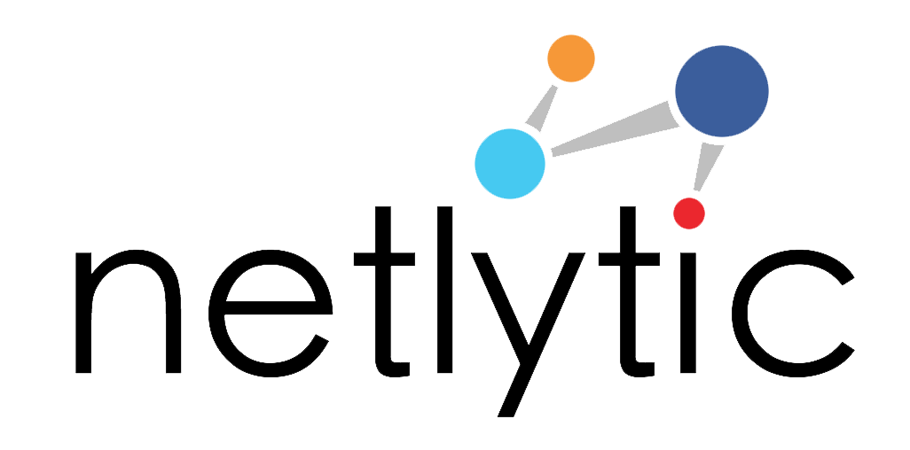

[Please feel free to modify/reuse this assignment in your class]

Sample Social Media Analytics Assignment
It’s All About the Data: Working with CSV Files
This assignment introduces students to building data using specific formatting criteria and converting data into readable file formats.
Objectives:
Objective 1: Introduce students to building data and understanding how network visualizations are created.
Objective 2: Learn how to convert data into specific formats to be used in open source analysis tool.
Objective 3: Create a chain network to understand how raw data is transformed to visualize a learning network.

Software: Netlytic (https://netlytic.org)

Software Documentation (Videos and Guides): https://netlytic.org/home/?page_id=11280
Data Source: Publically available social media data from Twitter, Facebook, Instagram or YouTube. Datasets for this assignment will be collected by students using Netlytic.
Preparation:
- Instructor to divide class into groups of 5-6 students
- Students to review Netlytic Tutorials on importing using Text Files, Text Analysis and Network Analysis
Main Steps:
- In assigned groups, each student will create a spreadsheet with the headers “from” and “to” to record their learning interactions with others in the group. In the “from” column, students will place their name; in the “to” column, students will list all of the other members in the groups that they have worked with in class or on a project.
Example
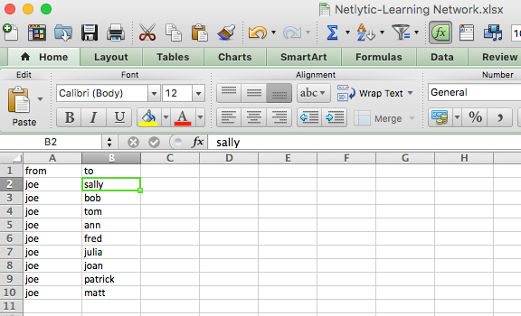
- Students will then aggregate all of the individual lists to create a master list and share with all members of the group.
- Next, students will save the file in CSV format and upload to Netlytic. Once the file has been properly uploaded students will run the network analysis and create a chain network to visualize their learning network.
Submission & Discussion
Students will submit a 1-page summary of their experience creating the dataset as a CSV, any challenges arising with formatting and conversion, and provide a screenshot of the chain network along with a brief explanation of the groups learning network.

Appendix A: Assigned Groups
Group | Students
Group 1
Group 2
Group 3
Group 4
Group 5

